Task No 1

Name Muhammad Ali

Sid 9363

Question: Configure Static Routing On Given Network

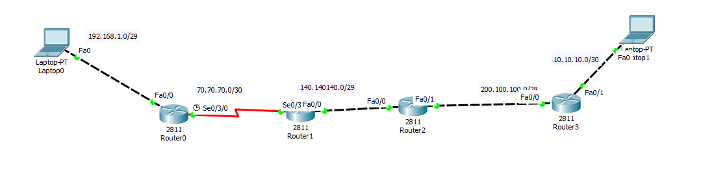

Router 1



Router 2

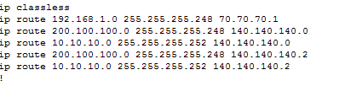

Router 3



Router 4



Question:

Configure Recursive Routing On Given Network

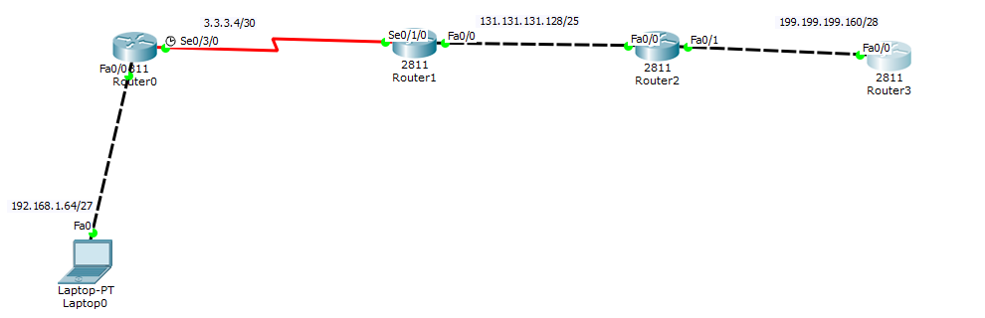

Router 1



Router 2



Router 3



Router 4

